Project Update
Contract Number N39430-17-C-1933

July 7, 2018 – Doc #3047-005
Table of Contents
Installation of PSA System and Plant Modifications 2
Results of Preliminary Testing 3
Discussion of the Performance and Theory of Current PSA System 4
Adsorption Overview 4
Driving Forces for Adsorption and Desorption 6
Interaction Effects of Gas Species 7
Adsorbent Selection 8
Complications Due to Cyclic Nature of PSA Process 8
Contamination Due to Pressure Equalization 9
Complications Due to Low H₂ Content of the Feed Gas 9
Recommendations for Future Implementations: 11
Decoupling H₂O and CO₂ Removal Using Two Stage Approach 11
Recycling Second Stage Tail Gas to Compressor Inlet 11

Executive Summary
This report summarized the work completed on the PSA system in preparation for processing hazardous waste feed material from PSNS.
A significant amount of testing has been completed to date over the course of 6 total processing days. Gas samples taken from this testing have not yet met the specifications given to the PSA vendor Xebec in the purchase agreement. Work is currently underway under warranty with the vendor to design and construct a second stage modification to allow the system to perform to specification.
An outline of the theory and operation of PSA systems is provided to better allow readers to understand the nature of the technical issues and the reasoning behind the proposed solutions.

Installation of PSA System and Plant Modifications
In order to install the PSA system at InEnTec’s technology development center, significant changes to the process gas piping and compression skid were required. Modifications that were made included the following:
- Installation of PSA system and interconnecting piping and flow meters.
- Modification of gas piping to allow for controlled pressurized operation on the inlet to the compressor. These modifications included upgrading the blower motor capacity and adding a control valve to increase the back pressure on the system.
- Installation of flow meters to allow for accurate measurement of process gas flows.
- Rebuilding the syngas compressor skid. The compressor used is a small experimental reciprocating unit that requires frequent replacement of the internal parts. Much of the complications with the maintenance of this compressor system stem from the requirements for handling a toxic and potentially explosive gas under compression.
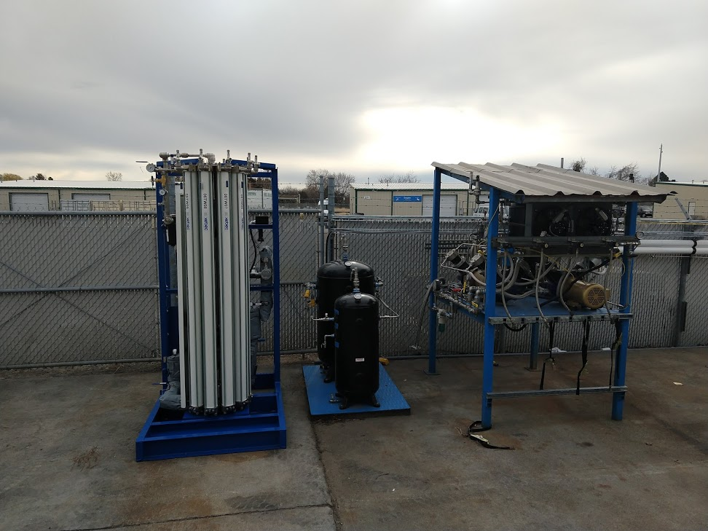

Results of Preliminary Testing
In preparation for testing with feed provided from PSNS, preliminary shakedown testing was conducted with the PSA unit using non-hazardous feedstock in the PEM system. Six separate day long tests were conducted using the PSA system and samples were taken during each test to assess the purity of the product being generated.
The first test was a shakedown test with staff from Xebec onsite to do process tuning. This was a necessary step to ensure the validity of the warranty on the unit. A Xebec technician used this test to tune the system such that it pressurized and depressurized at the proper rate during pressure equalization steps.
Following this test, the system was operated again approximately 1 week later under the guidance of Xebec staff. The results of this testing indicated that the current bed fill was not working properly and that the purity and performance requirements of the unit were not being met. At this point, Xebec shipped the beds back to their facility at their cost under warranty to modify the bed fill provided within the beds. The modification that was made was the addition of an activated carbon layer in the bed above the desiccant layer to remove CO2 prior to the upper zeolite layers.
After the beds were received back with the modified adsorbent layers, they were again tested on multiple occasions with multiple valve speeds and processing parameters. At this point Xebec determined that the PSA unit would not work as designed to provide the purity and recovery specified. Work is currently under way to resolve this issue and to add a secondary PSA unit after the current unit to meet the purity specifications.
In the table below, the purity and recovery calculations are shown for each of the test analyses done.
As can be seen, at no point was the 99.999% purity specification met with any significant level of recovery.

Discussion of the Performance and Theory of Current PSA System
In the following section, a background on the PSA system is provided and the performance of the system is discussed relative to adsorption theory. This section is provided to help better understand the performance of the PSA system and address the performance and purity issues that have been seen in its operation to date.

Adsorption Overview
The process used to separate hydrogen from the syngas stream created using the PEM process is the pressure swing adsorption (PSA) process. This is a common chemical process in which the pressure in adsorbent beds is manipulated to allow preferential adsorption and separation of each of the component species in the syngas stream. Adsorption is the process by which a molecule will tend to stick to a surface. Typical adsorbents are porous solid granular materials with high surface area to volume ratios and an affinity for a particular type of molecule.
For the separation of hydrogen from syngas, multilayered beds are used in which each component is adsorbed separately in series as gas flows from the bottom of the column to the top. Hydrogen is not adsorbed to a significant degree by the beds and it exits the top of the column as the product. As gas components are adsorbed within the PSA column, eventually a point is reached where the adsorbent material is at capacity. At this point, the component will no longer be removed and is free to pass through to the outlet of the column.
To prevent contaminants from passing through to the product stream, when the beds are near capacity they are brought off line and depressurized to remove the adsorbed gas. This is done in a cyclical nature where one bed is constantly flowing hydrogen product through, while the other beds in the system are regenerating. In actual practice, beds are not completely loaded and unloaded with adsorbed material. Instead, a large amount of material remains in the adsorbent and the cycle only uses a fraction of the adsorbent capacity. As an example, a bed might adsorb to 80% of its capacity and then on the desorption step it could only drop to 60% loading. This bed would then cycle between 60 and 80% in what is called a cyclical steady state.
The gas that is adsorbed in the columns still will contain a significant amount of hydrogen, and as a result, it is critical to reuse this gas in order to achieve a high level of recovery of the hydrogen fed to the system. As a result, most advanced PSA systems feature steps in which the gas from the pressurized but spent column is recycled back into unspent beds to gradually pressurize them. These intermediate steps are called pressure equalization steps as they are done by connecting the vessels and allowing pressure to equilibrate.
In general, the greater the number of beds, the better the recovery of hydrogen is expected as there can be more repressurization steps. A greater number of repressurization steps improves the utilization of the pressurized gas and results in a higher recovery of hydrogen. The only hydrogen that is lost from the process is in a final venting step, and when there are more beds (and consequently more pressure equalization steps) this venting occurs from a lower pressure and consumes less gas.
For example, in a two-bed configuration, after the first bed is spent pressure is equalized between the vessels to recover some of the hydrogen in the spent bed. There will still be approximately half of the pressure left in the first vessel (and consequently half the gas) after this pressure equalization step. This gas which contains a significant hydrogen fraction cannot be recovered. The gas would then be vented, resulting in significant decreases in the recovery of hydrogen. On the other hand, if you had three beds, the remaining gas could be used to pressurize another vessel and less venting would be required in the final step. This effect continues with the addition of each additional bed and the total vented flow decreases with a larger number of beds.
Many different PSA configurations are available in industry, and the primary differences between such systems is the pressurization steps taken and configuration of the valving used. The process selected this application was a rotary valve system provided by Xebec Adsorption Inc. Unique to this process is the use of a two rotary valves to control gas flows among 9 adsoption beds. For small scale applications, this system has the advantage of significantly lower cost and the potential for higher efficiency.
Other PSA designs feature multiple individual control valves for the inlet and outlet of each bed, and as a result, the cost of such systems is quite high, particularly for systems featuring a large number of beds. For instance, in a typical 4 bed setup upwards of 20 individual control valves are used. This valving escalates the cost and complexity of such systems, and as a result PSA systems are not typically utilized for small to moderately sized systems. Of the available PSA vendors that were identified, only Xebec elected to bid on the project.
An example of the pressure cycle used in the Xebec PSA system is shown in the figure below. Cells marked in green represent the stage that is producing product gas at each point in the cycle, while the yellow cells represent the beds that are venting their pressure to produce tail gas.
Below is a schematic showing how the beds are interconnected in the PSA unit.
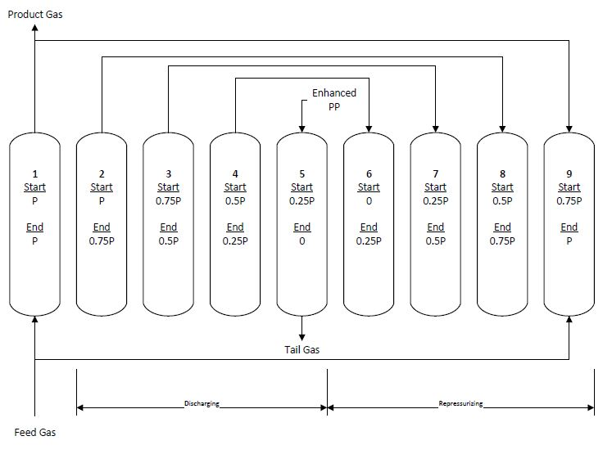
The Xebec PSA is controlled by altering the rotational speed of the rotary valves. The system features two rotary valves that are tied together at the same rotational speed. A valve is located at both the top and bottom of the column.
Higher valve speeds correspond to faster cycle times. This results in a greater fraction of the gas going to the tail gas stream and lower recovery as each cycle 1 chamber is vented to the tail gas stream. The intermediate pressures are not altered by changing the rotational speed of the unit and the product gas flow is controlled by the pressure differential across the PSA unit and is roughly constant regardless of rotational speed. In practice this leads to the need to adjust the valve speed to accommodate larger flows as adjusting the valve speed allows for the larger tail gas flow needed for larger flows of gas through the system.
Increasing the valve speed for a given flow rate will increase the purity of the product stream as with shorter cycle times, less adsorption is needed in each step. Due to this there is a tradeoff between purity and recovery in the PSA system.

Driving Forces for Adsorption and Desorption
The driving force for separation in an adsorption column is the partial pressure of a species in the gas stream. When the partial pressure in the gas space is higher than the partial pressure in the adsorbed phase, there is a net adsorption of a component into the adsorbent media. When the partial pressure is decreased and is lower in the gas phase, there is a net desorption. It is important to not that partial pressure is gas specific and that the driving force for adsorption of one gas can be in the opposite direction of another gas at the same location.
During the adsorption phase of a PSA cycle, the pressure in the gas phase of the chamber is high, and contaminant concentration is also high. As a result, partial pressures are higher in the gas phase than in the adsorbed phase and there is net adsorption.
The partial pressure in the gas phase is balanced by what can be thought of as the corollary to vapor pressure in a vapor / liquid equilibrium system. The degree to which each component sticks to the adsorbent will determine how much partial pressure will be given off by a certain amount of gas in the adsorbed phase. A component that sticks strongly to the adsorbent will have less partial pressure in the adsorbent compared to a weakly adsorbed component.
In addition, as the adsorbent fills it will eventually get to a point where there is no more capacity for interactive effects on the surface and there will be less of a reduction of partial pressure due to adherence to the surface. When this occurs, partial pressure in the adsorbent will increase and the net flux onto the adsorbent surface will decrease.
When the pressure in the bed is later dropped, the partial pressure of the adsorbed species in the gas phase drops and there is a net flux of the species out of the adsorbed phase due to the partial pressure of the species on the adsorbent surface.

Interaction Effects of Gas Species
As explained previously, as an adsorbent fills, the partial pressure provided by each additional adsorbed molecule increases. For adsorption to proceed at an appreciable rate, capacity in the adsorbent needs to be present. Once complication that occurs that affects adsorbent capacity when dealing with multiple adsorbing gas species is adsorbent capacity being taken preferentially by one component relative to another.
Take for example the adsorption of a strongly adsorbed and weakly adsorbed species competing for space in the same adsorbent. The strongly adsorbed species will have a smaller partial pressure once adsorbed on the surface and as a result will have a stronger driving force for adsorption. The weakly adsorbed species will have a smaller driving force for adsorption due to higher partial pressures on the surface of the adsorbent due to the weaker interaction. If equal amounts of each species is competing for the same space on an adsorbent of limited capacity, the strongly adsorbed component will take up a larger portion of the available capacity.
This process in compounded when the cyclic nature of the PSA process is taken into account. Not only is the strongly adsorbed species more readily adsorbed, it is also less readily desorbed. This means that during the desorption step less of the strongly adsorbed material will be desorbed and will still occupy some of the adsorbent sites during the next cycle. If the strongly adsorbed component is very strongly adsorbed, there will be little partial pressure provided while it is adsorbed on the surface and an equilibrium loading within the adsorbent will be reached in which the composition of the strongly adsorbed component on the surface is quite high relative to the more weakly adsorbed component.

Adsorbent Selection
The PSA system that is in use features a multiple layers of different adsorbents. Each adsorbent is selected based on its unique properties and affinity for a certain type of molecule. A component that is strongly adsorbed on one adsorbent may be weakly adsorbed on another adsorbent material and visa versa.
Four adsorbents are currently in use in the PSA system:
- Aluminosilicate Dessicant: This adsorbent is used for the removal of water vapor from the gas stream. Water vapor is present in the gas stream at low levels, but it can interact with later layers of the PSA system so it is preferentially removed first.
- Activated Carbon: Activated carbon is used for the removal of CO₂ and any remaining water vapor. CO2 is adsorbed more weakly onto the activated carbon layer than the later zeolite stages, but it is preferred to remove it here due to its relative difficulty of desorption.
- 5A Zeolite: The primary role of the 5A zeolite layer is removal of CO, CH₄ and a portion of the N₂ in the remaining gas. Any CO₂ that passes through the activated carbon layer will be removed here as well. The 5A zeolite adsorbs CO₂ strongly and as a result, CO₂ adsorbed by this layer can displace other species and consume a larger portion of the available surface sites as it is more weakly desorbed.
- CaX Zeolite: This zeolite is selected for its affinity for nitrogen and oxygen. Nitrogen is a weakly adsorbed species on nearly all media, and CaX is no exception. Due to its weak adsorption and the relatively strong adsorption of other species on the CaX adsorbent (particularly water vapor and CO₂), it is desirable to keep their concentration to a minimum and to allow the greatest possible availability of adsorption sites for the more difficult to remove nitrogen species.

Complications Due to Cyclic Nature of PSA Process
If the beds were set up as they are currently with virgin adsorbent and pressurized to full pressure, it is likely that on a first pass, the purity would be extremely high. There would be ample adsorbent sites available to store all contaminants in the gas stream. The majority of issues that affect the purity arise from the finite storage capacity of the adsorbents and the selection of the cyclical steps used to regenerate the beds.
It is theorized that the issues that have been seen with the attainment of the desired purity stem from the desorption process itself and are caused by the readsorption of species in the upper layers of the adsorbent bed.
The initial species to be desorbed in the beds as pressure is dropped is nitrogen. This leaves open adsorption sites on the upper zeolite layers of the beds as gases exit from the top of the column. As pressure is further dropped, CO₂ and H₂O are released from the activated carbon and dessicant layers. These species are then free to interact with the open sites on the upper zeolite layers where they are quite strongly adsorbed. With further depressurization some of the readsorbed species may desorb, but it is likely that a significant fraction remains adsorbed and takes up adsorbent capacity needed for nitrogen desorption due to the elevated partial pressures in the gas stream due to the continued desorption of the species from the activated carbon and desiccant layers.
When the bed is repressurized and adsorption commences, a couple of negative effects can occur. The first is that the capacity of the upper layers for adsorption of N₂ and CO are significantly diminished. Nitrogen has proven to be the most difficult species to remove and consequently N₂ adsorbent capacity is critical. When capacity is inadequate, nitrogen will pass through into the product stream.
The second effect is that desorption of H₂O and CO₂ can now occur in the upper layers of the bed and make it into the product stream. Recall that desorption is driven by the partial pressure of individual species of gas. When the bed is operating in its adsorption phase, H₂O and CO₂ are removed from the incoming gas resulting in a gas sweeping past the upper adsorbent layers that has a negligible partial pressure of these species. While the partial pressure of these species in the adsorbed layer is not high, it is still adequate to drive desorption of these species and contaminate the product despite the fact that the adsorption layers in which these components are designed to be removed are working perfectly.

Contamination Due to Pressure Equalization
It should be noted that a majority of the gas used to repressurize the vessels comes from pressure equalization with depressurizing vessels. This equalization occurs in the top of the columns and as a result, the pressurization gas flows over and will interact with the upper zeolite layers of the PSA column.
The gas used to pressurize the vessels is also a carrier gas for desorbed species. Desorbed species will be contained in these repressurization steps and the upper layers of the bed will be exposed to these gases. The first gas that these upper layers will be exposed to will be the least readily adsorbed gases in the gas stream. These gases are expected to desorb later in the process when the desorption pressure is lower. However, the lower desorption pressure steps are also the steps used to repressurize the beds after they have been vented. As a result, it is likely that the upper layers of the bed are exposed to H₂O and CO₂ in the repressurization step. Similar behavior of the bed is expected as these species will consume adsorbent space in the upper zeolite layers leaving less room for N₂ adsorption.
An additional complication is that the last step of the repressurization is likely where the upper layers will see the highest exposure to nitrogen as it is the first desorbed of the species. At this point, the upper layers of the bed will have been exposed to CO2 and H2O and will have limited adsorption capacity. Consequently, when the bed is finally brought online, there is a chance that there is non-adsorbed N₂ contamination present in the upper section of the column where product is drawn off.

Complications Due to Low H₂ Content of the Feed Gas
Xebec has significant experience with the construction of PSA units for use with more typical gas stream used as sources for hydrogen generations. The common factor behind all of these sources is a higher feed concentration of hydrogen, typically in the 60-80% H₂ range as compared to the 30-40% H₂ range generated by gasification.
The issue that arises from this difference is that tail gas flows within the column are higher when the composition of hydrogen is lower in the feed gas stream. With fixed volume chambers and set pressures, this results in higher partial pressures of contaminants in the pressure equalization steps. This will result in lower rates of desorption, higher required total desorption rates, and higher rates of readsorption in upper layers of the beds.
The velocity changes of the gases in the beds are also of concern. Greater removal of gases will result in larger changes in gas velocities. Whereas in a typical steam methane reformer (SMR) gas operation the drop in gas volume would be 30%, in a gasification system, the drop in volume could be up to 70%.

Recommendations for Future Implementations:
Based on the issues that have been seen, it is recommended to implement the following design changes and considerations in future installations of PSA units for gasification units.

Decoupling H₂O and CO₂ Removal Using Two Stage Approach
It is recommended to use a two-stage approach in which H₂O and CO₂ are removed in the primary stage. The tail gas from this process would be then removed from the process which would limit the exposure of the upper zeolite layers of the bed to these strongly adsorbed species. With these species removed, the process of removal of the other components would be significantly easier and more effective.

Recycling Second Stage Tail Gas to Compressor Inlet
With a two stage approach, significant improvements to the recovery of hydrogen can be seen when a portion of the tail gas from the second unit is recompressed and sent back through the first unit. With complete recycle of the tail gas from the second unit, the overall process recovery of H₂ will match that of the first unit. However, if the first unit does not remove nitrogen, it will build up in concentration in the system and contaminate the off gas stream.

